‹Illustrative migration› — assumptions readout
As of 2026-10-06 · Archetype C · Departure platform → arrival platform · Phase 1: ‹markets›, ‹date› · phase 2: ‹markets›, ‹date›

1. Headline
The plan is 132 FTE against a departure baseline of 104 (+28), built from the client's own history and the differences called on the grid.
The open assumptions keep it a range rather than a point. Taken one at a time, the five most uncertain move the plan by between −12 and +14 FTE; if all five broke the same way, by −43 to +48. The one to confirm first is contacts per transaction, by country (R1, −10 / +12, Asserted).
3 problems need action before go-live, 6 differences are carried in the plan as Watch, and 2 values are not yet held. 13 clarifying questions are open; 7 of 16 mandatory rows for the declared archetype are still empty.

2. How the number was built
Departure baseline: 104 FTE — Client's own history for the migrating markets, pre-migration months only.
Approach question | Answer
Contacts per transaction: rate, denominator, source | 0.31 per transaction from the client's own pre-migration months; denominator is transactions, not customers
Broken to country level? | Yes, by country
Departure data: what we hold, and how clean | Twelve months held; two months contaminated by an outage
Channel split today → expected | Chat 38% today → 45% expected (chat becomes the default)
Seasonality: does the client's own shape hold? | Assumed to hold; Q1 peak carried across
What we deliberately did not model, and why | Concurrency above one: not offered at arrival
Mandatory rows still empty (7 of 16): #2 What moves: markets or countries, populations, phases and dates; #7 Transaction volume, and its definition on both sides; #20 Channel usage share; #22 Entry points, caller identification and security time; #24 Channel usage share and turnaround target; #26 AHT baseline by channel and country, from the client's own history; #35 Incoming plan laid against the outgoing plan before go-live. Each has an open question in section 6.

3. Bridge and sensitivity
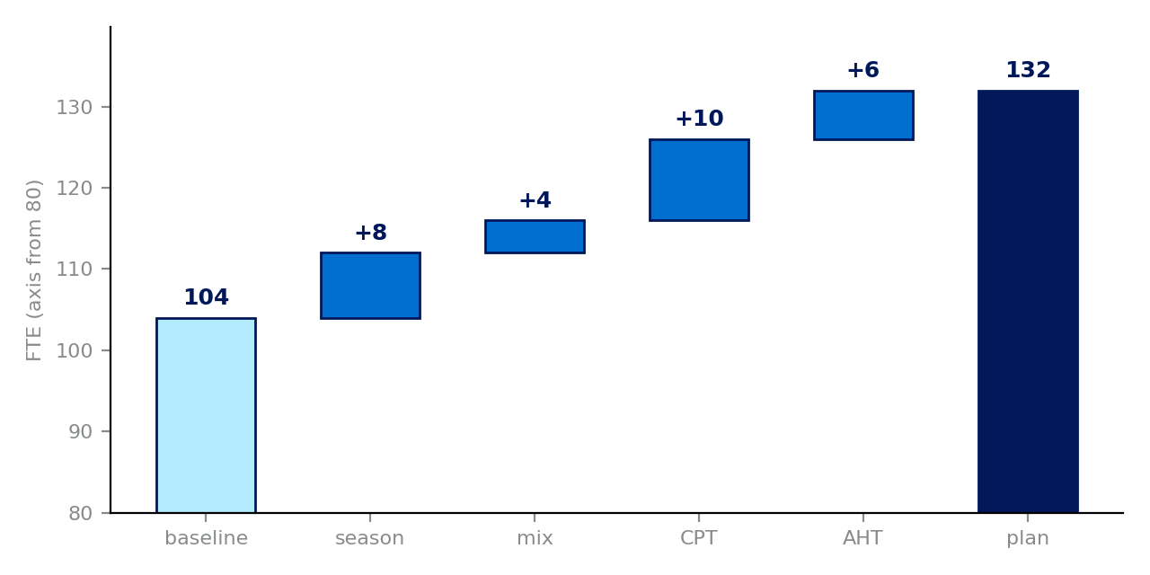
Step | FTE | Running total
baseline |  | 104
season | +8 | 112
mix | +4 | 116
CPT | +10 | 126
AHT | +6 | 132
plan |  | 132
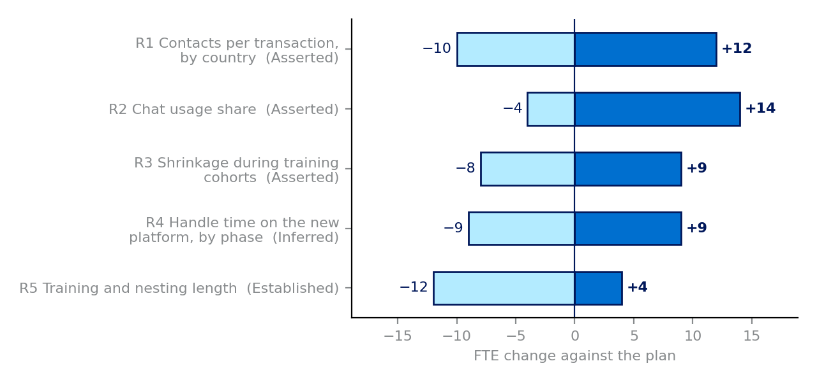
R | Characteristic | Low | High | Evidence | Score
R1 | Contacts per transaction, by country | −10 | +12 | Asserted | 17.6
R2 | Chat usage share | −4 | +14 | Asserted | 14.4
R3 | Shrinkage during training cohorts | −8 | +9 | Asserted | 13.6
R4 | Handle time on the new platform, by phase | −9 | +9 | Inferred | 9
R5 | Training and nesting length | −12 | +4 | Established | 3.2
The bridge adds each difference's central FTE effect to the departure baseline, by what it drives. The ranking multiplies the width of each open row's range by the weakness of its evidence (Open 1.0 · Asserted 0.8 · Inferred 0.5 · Established 0.2).

4. Problems, unknowns and actions
# | Characteristic | Departure → arrival | FTE | Owner | By | Next action
3 | Operating model | One 24-hour pool → In-country, business hours | +4 | arrival lead | 2026-10-20 | What range should the loss of pooling from in-country teams carry? Row 3 has +4 central and no range.
8 | Contacts per transaction, by country | 0.31 — own pre-migration months → 0.34 — new entry points | +10 | departure lead | 2026-10-20 | Contacts per transaction of 0.31: which months, which markets, and what is the denominator? An export would move row 8 from Asserted to Established.
17 | Languages supported | EU + Asia → EU only | not sized | arrival lead | 2026-10-20 | Which languages will the arriving teams cover at go-live, and where does work in the uncovered language go?
Values not yet held:
# | Characteristic | Owner | By | Status
14 | How chat behaves: sync or async | arrival lead | 2026-10-20 | open
34 | Client told what will change | sponsor | 2026-10-20 | open

5. Top five open assumptions
R | Characteristic | Range (FTE) | Evidence | Score | Owner | What would close it
R1 | Contacts per transaction, by country | −10 / +12 | Asserted | 17.6 | departure lead | Contacts per transaction of 0.31: which months, which markets, and what is the denominator? An export would move row 8 from Asserted to Established.
R2 | Chat usage share | −4 / +14 | Asserted | 14.4 | arrival lead | A measured value with its source
R3 | Shrinkage during training cohorts | −8 / +9 | Asserted | 13.6 | operations lead | A measured value with its source
R4 | Handle time on the new platform, by phase | −9 / +9 | Inferred | 9 | arrival lead | For how many weeks does phase-1 handle time stay above steady state?
R5 | Training and nesting length | −12 / +4 | Established | 3.2 | operations lead | A measured value with its source

6. Open questions by owner

Arrival lead
- Q1 (row 14, asked): At arrival, does chat run synchronously or asynchronously? The planning call left it as 'to confirm'. — Closes row 14; sets its handle-time effect
- Q3 (row 17, open): Which languages will the arriving teams cover at go-live, and where does work in the uncovered language go? — Row 17 is a Problem; decides whether the work can land
- Q5 (row 3, open): What range should the loss of pooling from in-country teams carry? Row 3 has +4 central and no range. — Row 3 cannot be ranked without a range
- Q8 (row 27, open): For how many weeks does phase-1 handle time stay above steady state? — Row 27 ranks R4; sets how long the phase-1 premium is carried
- Q12 (row 22, open): Which entry points will customers use at arrival, and how long will caller identification take? — Row 22 is mandatory for C and empty; moves handle time

Sponsor
- Q2 (row 34, open): Has the client been told that its own chat is being replaced, and by when? — Closes row 34; contacts keep arriving on a channel switched off on paper
- Q15 (row 35, open): When will the incoming plan be laid against the outgoing plan, and who signs it? — Row 35 is mandatory and empty; Rule 3

Departure lead
- Q4 (row 8, asked): Contacts per transaction of 0.31: which months, which markets, and what is the denominator? An export would move row 8 from Asserted to Established. — Row 8 ranks R1; the widest range on the register
- Q9 (row 2, open): Which markets move in each phase, and on what dates? — Row 2 is mandatory and empty; sets the country split
- Q10 (row 7, open): What is the transaction volume for the migrating markets, and is a transaction defined the same way on both sides? — Row 7 is mandatory and empty; the contact rate's denominator
- Q11 (row 20, open): What share of contacts arrives by voice today, and what share is expected after the move? — Row 20 is mandatory and empty; the channel split
- Q13 (row 24, open): What share arrives by email today, and what turnaround applies at arrival? — Row 24 is mandatory and empty; the channel split
- Q14 (row 26, open): What is handle time by channel and country in the client's own pre-migration months? — Row 26 is mandatory and empty; the handle-time baseline

7. What changed
All logged changes: no previous readout date was given.
Date | Row | What changed | Said by | Evidence | FTE | Model updated?
2026-10-12 | 27 | Phase-1 handle time set above steady state: 420 s vs 390 s | arrival lead | Inferred | 6 | Yes
2026-10-12 | 34 | Asked: has the client been told its own chat is being replaced? | sponsor | Open |  | No
2026-10-05 | 3 | Sizing basis: one 24-hour pool → in-country, business-hours pools | arrival lead | Inferred | 4 | Yes

Appendix: the grid
# | Group | Characteristic | Departure | Arrival | Call | Drives | Central | Low | High | Evidence | Owner | Date
1 | Setting the table | Archetype, declared first (recorded on Set the table) |  |  |  | Several
2 | Setting the table | What moves: markets or countries, populations, phases and dates |  |  |  | Supply timing
3 | Setting the table | Operating model | One 24-hour pool | In-country, business hours | Problem | Pooling | +4 |  |  | Inferred | arrival lead | 2026-10-20
4 | Setting the table | Language model: English-only vs language-based |  |  |  | Pooling
5 | Setting the table | Servicing model: dedicated · designated · shared |  |  |  | Pooling
6 | Setting the table | Tools and platform: transaction tool, desktop, CRM, knowledge base |  |  |  | AHT
7 | Demand | Transaction volume, and its definition on both sides |  |  |  | CPT / volume
8 | Demand | Contacts per transaction, by country | 0.31 — own pre-migration months | 0.34 — new entry points | Problem | CPT / volume | +10 | −10 | +12 | Asserted | departure lead | 2026-10-20
9 | Demand | Seasonality and weekly shape | Q1 peak in own history | Same shape assumed | Watch | Volume shape | +8 | −2 | +3 | Inferred | departure lead | 2026-10-20
10 | Demand | Adoption ramp: share of users moved per phase |  |  |  | CPT / volume
11 | Demand | Self-service and deflection (online adoption, bot) |  |  |  | CPT / volume
12 | Demand | Contact conversion: deferred email turning into voice or chat; re-contacts |  |  |  | CPT / volume
13 | Chat | Chat usage share | 38% | 45%, chat is the default | Watch | CPT / volume | 0 | −4 | +14 | Asserted | arrival lead | 2026-10-20
14 | Chat | How chat behaves: sync or async | Synchronous | To confirm | Unknown | AHT |  |  |  | Open | arrival lead | 2026-10-20
15 | Chat | Chat timeout | 10 min | 15 min | Acceptable | Abandonment |  |  |  | Established | arrival lead
16 | Chat | Concurrency modeled vs achieved |  |  |  | Concurrency
17 | Chat | Languages supported | EU + Asia | EU only | Problem | Pooling |  |  |  | Established | arrival lead | 2026-10-20
18 | Chat | Bot or automation element |  |  |  | CPT / volume
19 | Chat | Service level target and hours |  |  |  | Service level
20 | Voice | Channel usage share |  |  |  | CPT / volume
21 | Voice | IVR and routing design (menus, skills, overflow) |  |  |  | AHT
22 | Voice | Entry points, caller identification and security time |  |  |  | AHT
23 | Voice | Service level target | 70/30 | 80/20 | Watch | Service level | 0 | −1 | +2 | Established | arrival lead | 2026-10-20
24 | Email | Channel usage share and turnaround target |  |  |  | CPT / volume
25 | Handle time | AHT definition | Agent work only | Agent work only | Same | AHT |  |  |  | Established | both leads
26 | Handle time | AHT baseline by channel and country, from the client's own history |  |  |  | AHT
27 | Handle time | Handle time on the new platform, by phase | 380 s | 420 s phase 1, 390 s after | Watch | AHT | +6 | −9 | +9 | Inferred | arrival lead | 2026-10-20
28 | Handle time | Tenure and proficiency; knowledge lost with departing staff |  |  |  | AHT
29 | Supply | Shrinkage during training cohorts | 32% | 36% | Watch | Shrinkage | 0 | −8 | +9 | Asserted | operations lead | 2026-10-20
30 | Supply | Training and nesting length | 6 weeks | 4 weeks | Watch | Supply timing | 0 | −12 | +4 | Established | operations lead | 2026-10-20
31 | Supply | Delivered capacity: heads to productive hours; plannable occupancy |  |  |  | Pooling
32 | Supply | Attrition and backfill lead time |  |  |  | Attrition
33 | Supply | Eligibility, notice periods and transfer law (people moving) |  |  |  | Supply timing
34 | Governance | Client told what will change | — | Not yet | Unknown | CPT / volume |  |  |  | Open | sponsor | 2026-10-20
35 | Governance | Incoming plan laid against the outgoing plan before go-live |  |  |  | Several
36 | Governance | Buffer for other clients in the same wave |  |  |  | Supply timing

